
First 5 Amador

2023-2027 Strategic Plan

February 24, 2023

975 Broadway, Jackson, CA 95642 ~ (209) 257-1092





History

FIRST 5 AMADOR

COMMISSION AND STAFF

Joni Drake – (Commission Chair) – Site Manager, Amador County Tribal TANF Partnership
Richard Forster – Amador County Board of Supervisors (District 2)
Arleen Garland – Community Member (Grandparents Raising Grandchildren / Parenting Classes)
Angel LeSage– Retired Public Health Nurse (Pediatric Nurse Practitioner).

Nina Machado – Executive Director
Tracy Carlton – Project Coordinator
Tassie Earnest – Welcome Baby Coordinator
Shannon Puente – Early Learning Coordinator

First 5 Amador & Proposition 10
First 5 Amador (previously called the Amador County Children & Families Commission) was formed in December 1998 by the Amador County Board of Supervisors in under the California Children and Families First Act (Proposition 10/Prop 10).
Passed by California voters in November 1998, Prop 10 imposes a fifty-cent-per-pack state sales tax on tobacco to fund a comprehensive, integrated system of early childhood development services for California children ages 0-5. The overall intent of Prop 10 is to prepare all California children to enter school healthy and ready to learn. The funded activities must address three primary strategic results:
- Improved Family Functioning: Strong Families
- Improved Child Development: Children Learning and Ready for School
- Improved Child Health: Healthy Children
First 5 Amador adopted its first strategic plan in 2000 and identified three primary goal areas: Child Care, Family Violence Reduction, and Health Education. Subsequently, three additional goal areas, Family Resource Centers/access to services, School Readiness, and Family Strengthening, were added.
Since its inception, First 5 Amador’s Commission has met monthly to implement the strategic plan, evaluate investment results annually, and review and update the strategic plan annually.
The commission maintains an open and welcoming atmosphere during its meetings, which are open to the public in compliance with the Brown Act.


Sarah Boxx, Principal Sarah Boxx Coaching and Consulting planned, facilitated, and documented First 5 Amador’s Strategic Planning process.

Principles, Framework, and Roles

Principles
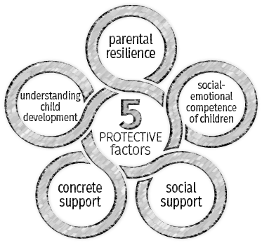
Our focus is preventing problems before they begin, commonly called working “upstream.” We look for existing assets in people and places and strengthen those simultaneously as we attend collaboratively to the challenges and needs of our county’s youngest children and their families. We want to know how investments of resources, time, and “talents” help achieve results and increase the probability of successes for increased accessibility, high-quality services and experiences, and overall sustainability.

framwork
First 5 Amador uses the Strengthening Families Protective Factors framework, which includes five research-based, family-centered factors and supports that ensure thriving children. The Five Protective Factors framework also guides investments, collaborations, and partnerships, communications, and initiatives.

Roles
We perform six roles as we implement our strategic plan on behalf of Amador’s children, ages prenatal through five and their families.
- Grant Making – Provide funding opportunities.
- Direct Service – Select services, programs, and activities that are developmentally, culturally, and linguistically appropriate for children and families / caregivers in Amador County.
- Communication, Community Education, and Advocacy – Raise awareness among community members, policymakers, providers, and parents about the importance of early childhood investments.
- Building Community Capacity – Support grantees, partner agencies, and other groups to strengthen their ability to provide services to families and early childhood educators.
- Convening Community Partners – Bring stakeholders together for planning, collaboration, and communication to improve systems.
- Explore local, regional, and state opportunities for sharing and leveraging resources and funding.

Mission and Vision

Mission

Our mission is to promote, support, and enhance the optimal development of Amador County's children from zero to five years of age.

Our Commission believes that broad community involvement is critical to the success of this mission. With Proposition 10 funds, we support projects that make sense locally based on identified needs and opportunities for children and families in Amador County.

vision

Our vision paints a picture of what the future looks like as we achieve success. We share it here in short, tangible, one sentence “stories.”

Every child has someone to encourage them. They achieve social and emotional skills at an early age and all levels of education. They demonstrate kindness and empathy with one another and are resilient – as are their families.

We have an effective, seamless process to identify children with learning disabilities and other issues.

There are multi-generational opportunities, and group educational/ learning experiences that include children and families with special needs.

There are safe spaces for families and children to connect and prepare children for kindergarten. Dads and uncles are involved and feel welcomed in group activities.

We have communities where children and adults feel heard, intelligent, capable, beautiful, and accepted.

Child abuse is radically reduced.

People feel it's easier to ask for help and support, and there is no shame in doing so.

There are more significant connections to each other, and a sense of community and belonging is prevalent.

We increasingly recognize the diversity of our children; our communities are more colorful, with a wide range of skin colors and persons with varying (dis)abilities.
Encouraged, Inclusive, Safe, and Resilient

Focus Areas, Goals, and Objectives

CHILD HEALTH AND WELLBEING
Goal 1. Families with children zero to 5 have optimal health and well-being.
- Objective 1.1 Families with children prenatal through 5 have access to oral health, social and emotional health, and health education opportunities.

SCHOOL READINESS
Goal 2. Children are ready for school/schools are prepared for all children.
- Objective 2.1 Children have access to quality early education opportunities.
- Objective 2.2 Children with social/ emotional issues and special needs are identified early and receive support.
- Objective 2.3 Schools are prepared for children, and the community is linked with the schools.

family/parent support
Goal 3 Families and caregivers have support and access to relevant information.
- Objective 3.1 Families/ caregivers have access to information, quality early education opportunities, social connections, and support to protect and promote their children's social and emotional development.

Systems
Goal 4: Systems are integrated and sustainable.
- Objective 4.1 Reevaluate and restructure Amador’s approach to reach families with children in outreaching/outlying areas of county.
- Objective 4.2 Explore alternative sites/ options for connecting at the local levels (Boy Scouts, veterans halls, community centers, churches, and libraries) using Jackson's model as the hub/central site with satellites in outlying areas.


Strategies and Activities

The strategies and activities supported through or funded by First 5 Amador intend to achieve the plan’s goals and objectives. Enhancing resilience, building connections, and leveraging existing partnerships and community assets are each essential in this work.

Current Strategies
- Bridge to Kindergarten*
- Community Activity Centers - continue to expand the concept and improve relationships; focusing on Pine Grove, Camanche, and other areas in the county, ensuring there are/is:
  - Consistent, dedicated staff.
  - Grassroots-driven versus organization/agency driven services.
  - Use of local facilities (e.g., libraries as resources)
- Diaper Program
- Early care and education-IMPACT/ QCC (Amador Quality for Kids)
- Father Engagement – using different models, e.g., kits/activities, drive-by events.
- Imagination Library
- Kick-off to Kindergarten (currently being revamped)
- Kindergarten Readiness Program*
- Messy Mornings
- Playgroups
- Social media messaging (e.g., Facebook, Next Door App) and E-newsletter
- Welcome Baby/Welcome Wagon – potentially adding home visiting or nurses.

* These strategies will depend on the impact of Transitional Kindergarten

As noted under the Evaluation section, First 5 Amador adjusts or modifies its investments based on evaluation results and input from the community. During the planning process, several “must” have strategies – those with increased participation and results, or that achieved the desired outcomes - were identified. Some are already in place, while others will take time to create/expand existing partnerships and community resources.
We seek strategies and activities that demonstrate aspects of successful programs, interactions, and partnerships (beyond or in addition to the evaluation results). These strategies include:

- Family connections and support
- Consistency
- Makerspaces for adults and kids
- Extended hours for working parents.
- Family diversity (inclusive of all ages)
- Modeling positive behaviors, interactions, expectations, etc.
- Successful connection to parents, caregivers, and family members

other Opportunities to connect where families gather
The planning group identified another set of opportunities for serving and supporting children ages 0 to 5 and their families and caregivers. Some are already up and running, while others would require expanded partnerships and approaches. Each can reach and benefit many children and their families and caregivers. First 5 Amador will consider each as they implement this plan over the next five years.

- After-School Activities
- Arts- Visual, Drama, Dance
- Bowling Alley
- Community Based Organizations
  - California Tribal TANF Workshops
  - Immunization Clinics
  - Food Banks
  - WIC
  - Others
- County and State Parks
- County Fair
- Dance Classes and Recitals
- Events
  - Ione Christmas Parade
  - School Events
  - Celebrate Our Children
- Faith-Based Organizations and Churches
- Health and Human Services (e.g., Public Health, Social Services, Child Welfare System, Behavioral Health), other public agencies
- Hospital Supports/Classes (Maternal Connections - peri/postpartum moms, Boot Camp for New Dads)
- Howard Park- Ione
  - Little League
  - Soccer
  - Girls softball
- Little Free Libraries
- Lower Income Apartment Complexes
- Medical offices
- Play Groups-Formal and Organic/Pop-Up Groups
- Playgrounds
- Recreation Center
- Satellite Libraries
- Schools-Including Public, Private, and Homeschools
- Sporting Events and Activities
- Supermarkets and Grocery Stores

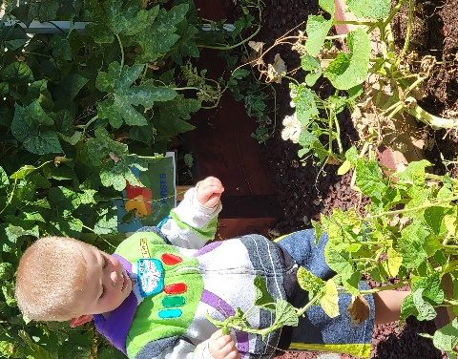
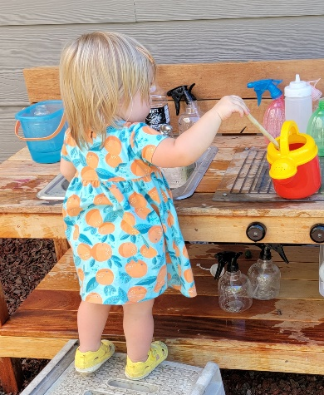
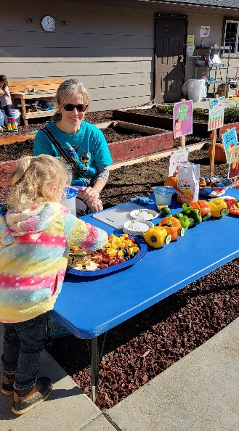

Evaluation – Purpose and Approach

Purpose
First 5 Amador is required to conduct evaluations annually. The evaluation results are used to:
- Guide program implementation and ongoing improvement.
- Communicate key findings and successful approaches for supporting children ages 0 – 5.
- Inform decision-making.
- Provide accountability and visibility to Amador County residents.

Approach
The Commission evaluates grantees/funded programs and initiatives progress twice each year. They use the results to identify and share successes and lessons learned with grantees/funded programs and the community.
When programs or projects encounter unexpected delays or obstacles, the bi-annual evaluation process allows the Commission to provide technical assistance and support when needed in a timely, proactive manner.
A common aspect of all evaluation processes is including customer and client feedback, whether through focus groups, surveys, or other avenues.
Projects funded through the RFP/RFA process participate in evaluation as follows:
- Semi-annually, grantees provide:
  - Updates to their project budget.
  - The number of persons served.
  - Services delivered.
- First 5 staff review the semi-annual updates and, if/when needed, provide support and technical assistance for “course correction.”

- First 5 staff and Commissioners visit with grantees to learn first-hand how the programs and services are delivered and what the results are. This evaluation component provides an opportunity to ask questions and learn more about the communities’ efforts on behalf of First 5 Amador's goals.

Financial Plan – Purpose and Approach

Tax revenues were forecast to decline from decreased tobacco use since the passage of Proposition 10 in 1998. Other efforts to tax tobacco and tobacco products have been enacted over the past two decades, which also affect tobacco use and the resulting tax revenue.
For this reason, the Commission also developed a Fiscal Plan as a companion to the Strategic Plan. The Fiscal Plan is managed as a separate document.
First 5 Amador strategically invests its revenues where we can,
- Leverage other financial and technical resources.
- Use financial and human resources with a view toward influencing systems change and engaging the community.
- Support training, assistance, and educational forums to promote the adoption of quality practices or programs.
- Continue to update and disseminate data to educate the community and secure financial resources.





Context & Considerations

for Planning

First 5 Amador has representation in other arenas of health and wellbeing, school readiness, and social connections through working alongside public and private organizations and nonprofits. The Commissioners also work or serve in these sectors, which allows the conversations of impact, collaboration, and results to remain informed and current.

Data from other studies, state initiatives, and programs inform the planning and implementation, as does formal and informal feedback from caregivers and families throughout the year.

This section of the plan contains some key points, as follows:

Pre-Planning Survey Summary. This content reflects a summary of the surveys First 5 issued to its program partners, program participants, and grantees.

Sutter Amador Hospital List of Prioritized Significant Health Needs. The list represents the 2022 update based on primary and secondary data sets.

Amador County Kids Data. We share a few charts showing trends in birthrates, child population for ages 0 to 2, and 3 to 5 years of age, living arrangements for children, and child population by race and ethnicity for 2021 in this section.

Amador County Behavioral Health Services Cultural Competence Plan 2. The information in this section describes more about the cultural diversity and current percentages of services and service penetration.

Strategic Planning - Pre-Retreat Survey Summary

INTRODUCTION
First 5 California approved funding for First 5 Amador County to develop programs and opportunities that support the needs of children and families within the county. Their mission is to promote, support, and enhance the optimal development of Amador County’s children, ages zero to five.
In October 2022, First 5 Amador surveyed program grantees, partners, and participants. The surveys were reviewed and then summarized in this document. The input gathered was used to assist the Commission in their planning process and inform their five-year strategic planning process.
Therefore, we acknowledge and thank those who took time to share their experiences, knowledge, and suggestions.

Overall Themes
A few consistent themes emerged across participant pools when analyzing the survey results from each of the three survey groups. These are explored in more detail as we examine challenges and capacity concerns.

CHALLENGES AND CAPACITY
CONCERNS EXPRESSED BY CAREGIVERS ACROSS SURVEYS
When asked to share recommendations about where First 5 Amador should invest its resources in its four focus areas, all three survey sub-groups identified the following themes.

 | Childcare. Childcare concerns included affordability, accessibility, quality, and hours of operation.  - Program participants identified childcare as a concern 16 times.  - Program partners identified childcare as a concern 8 times.  - Grantees identified childcare as a concern 0 times.
 | Finances. Financial concerns included the high cost of groceries, inflation, and rent support.  - Program participants identified finances as a concern 5 times.  - Program partners identified finances as a concern 7 times.  - Grantees identified finances as a concern 1 time.
 | Housing. Housing concerns included housing affordability and homelessness.  - Program participants identified housing as a concern 0 times.  - Program partners identified housing as a concern 7 times.  - Grantees identified housing as a concern 1 time.
 | Transportation. Transportation concerns included high fuel costs, access to transportation, and long commute times.  - Program participants identified transportation as a concern 2 times.  - Program partners identified transportation as a concern 4 times.  - Grantees identified transportation as a concern 1 time.
 | Social Skills Development. Social skills development concerns stemmed from isolation resulting from the COVID-19 pandemic.  - Program participants identified social skills development as a concern 5 times.  - Program partners identified social skills development as a concern 2 times.  - Grantees identified social skills development as a concern 2 times.

These five (5) areas were highlighted repeatedly throughout the surveys. The themes represent the primary concerns expressed by caregivers and parents.

LOOKING FORWARD
When asked to share recommendations about where First 5 Amador should invest its resources in each of its four focus areas the following themes were identified by all three survey sub-groups.

CHILD HEALTH AND WELLBEING
Mental Health Services. This was by far the most recommended area for First 5 investments, with 17 people noting it across the three sub-groups. Nearly half of the recommendations came from program partners, while one-third came from program participants: | - Program participants recommended mental health services as a focus area 6 times.  - Program partners recommended mental health services as a focus area 9 times.  - Grantees recommended mental health services as a focus area 2 times.
Dental Health Education and Services. After mental health, oral health was the next most recommended investment area. | - Program participants recommended dental health services as a focus area 3 times.  - Program partners recommended mental dental services as a focus area 2 times.  - Grantees recommended dental health services as a focus area 1 time.

SYSTEMS
Promoting and Providing Integrated Services Across Agencies. Integrated services and working across organizations ten times. | - Program participants recommended promoting and providing integrated services across agencies. as a focus area 2 times.  - Program partners recommended promoting and providing integrated services across agencies as a focus area 6 times.  - Grantees recommended promoting and providing integrated services across agencies as a focus area 2 times.

FAMILY AND CAREGIVER SUPPORT AND INFORMATION ACCESS
Quality Early Education Activities | - Program participants recommended early education as a focus area 3 times.  - Program partners recommended early education as a focus area 4 times.  - Grantees recommended early education as a focus area 2 times.
Promote Social and Emotional Development | - Program participants recommended promoting social and emotional development as a focus area 5 times.  - Program partners recommended promoting social and emotional development as a focus area 6 times.  - Grantees recommended promoting social and emotional development as a focus area 2 times.

SCHOOL READINESS
Social, Emotional, and Special Needs | - Program participants recommended supporting social, emotional, and special needs as a focus area 2 times.  - Program partners recommended supporting social, emotional, and special needs as a focus area 1 time.  - Grantees recommended supporting social, emotional, and special needs as a focus area 3 times.
Early Identification and Referrals | - Program participants recommended early identification and referrals as a focus area 6 times.  - Program partners recommended early identification and referrals as a focus area 5 times.  - Grantees recommended early identification and referrals as a focus area 1 time.

Sutter Amador Hospital - Prioritized Significant Health Needs (SHN)

Sutter Health updated the list of significant health needs in 2022 for Sutter Amador Hospital, as shown below in prioritized order.
1. Access to Quality Primary Care Health Services
2. Access to Mental/Behavioral Health and Substance Use Services
3. Access to Basic Needs Such as Housing, Jobs, and Food
4. Access to Specialty and Extended Care
5. Access to Functional Needs
6. Increased Community Connections
7. Active Living and Healthy Eating
8. Injury and Disease Prevention and Management
9. Safe and Violence-Free Environment

Process For Updating and Prioritizing the SHN List.
- Collect and analyze primary and secondary data for the service area, resulting in nine (9) SHNs.
- Primary data used to prioritize these SHNs. Prioritization was based on three measures of community input: key informant interview and focus group results, including the percentage of sources that identified a health need as existing in the community and the percentage of times the sources identified a health need as a top priority.
- The last measure was the percentage of community provider survey respondents identifying a health need as a top priority.

Use this link to access the full update:
https://www.sutterhealth.org/pdf/for-patients/chna/sah-2022-chna.pdf

The updated report also lists potentially available resources (128) to meet these needs in the service area.

Amador County Kids Data

https://www.kidsdata.org/region/1763/amador-county/summary#6/demographics

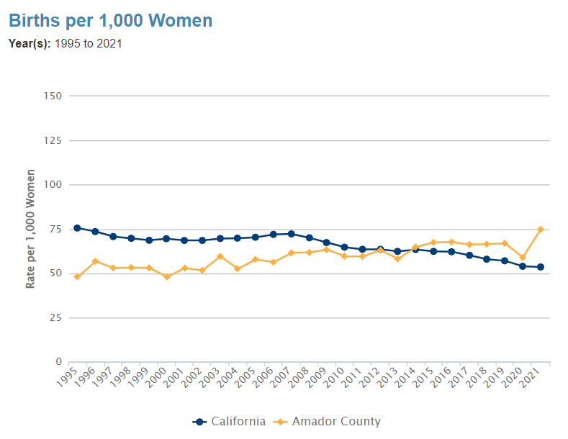
Birth Rate
Child and family demographic trends help project potential needs for education, childcare, health care, and other services.
While the State’s births per 1,000 women continue to decline, Amador County is experiencing a slight upward trend through 2021.

Child Population, by Age Group and Gender: 1995 to 2021
(Age Group: Ages 0-2, Ages 3-5; Gender: Total)
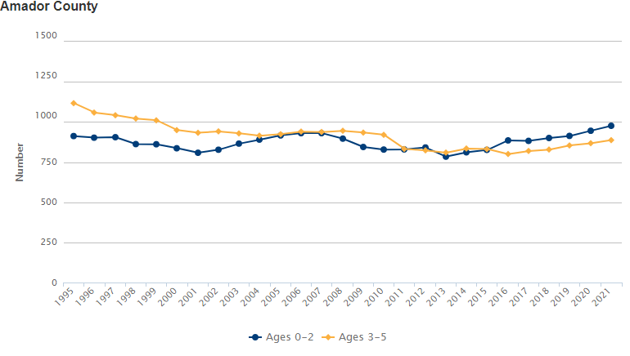

Child Population, by Race/Ethnicity: 2021
(Race/Ethnicity: All)
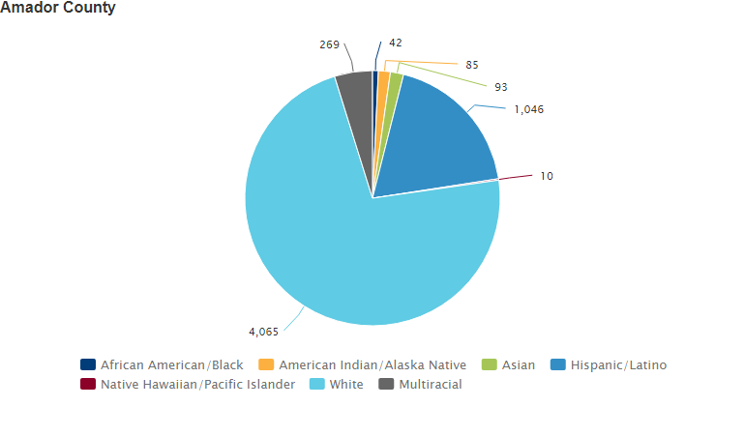
Definition: Estimated child population ages 0-17, by race/ethnicity. Data Source: As cited on kidsdata.org, California Dept. of Finance, Population Estimates and Projections; U.S. Census Bureau, Population and Housing Unit Estimates (Aug. 2021).

Living Arrangement for Children, by Presence of Parents (Regions of 10,000 Residents or More): 2014-2018
(Presence of Parents: All)

California | Percent
Two Parents Present | 63.8%
Mother Present Only | 23.6%
Father Present Only | 8.1%
No Parents Present: Other Relatives Present | 3.7%
No Parents or Other Relatives Present | 0.8%
Amador County | Percent
Two Parents Present | S*
Mother Present Only | 20.3%
Father Present Only | 9.1%
No Parents Present: Other Relatives Present | S*
No Parents or Other Relatives Present | 2.5%
Footnote: Parents in households with two parents present can be married or unmarried. Children in living arrangements with no parents or other relatives present include children in non-family households (e.g., non-kinship foster placements), children in group quarters, and those who are householders, spouses, or unmarried partners. *Data are displayed for geographies with at least 10,000 people based on 2018 population estimates.
Definition: Estimated percentage of children ages 0-17 living with and without parents or other relatives (e.g., in 2014-2018, 63.8% of California children were in living arrangements with two parents present).
Data Source: As cited on kidsdata.org, U.S. Census Bureau, American Community Survey (Jan. 2020).

Amador County Behavioral Health Services Cultural Competence Plan 2

Following are a few selected highlights from the Amador County Behavioral Health Services Cultural Competence Plan 2 that may influence how First 5 conducts outreach and implements its strategies.

Trends in serving ethnic populations from year to year.
“Although the penetration rates for each ethnic and racial population ACBH serves are high, when you analyze the #’s served, there is some work to be done in ensuring that each racial/ethnic group are targeted for outreach to support engagement and culturally responsive services.

“… after analyzing the data listed below the number of those eligible for each ethnic group has increased, however, the number of individuals served have not. Again, this points to the work that needs to be done regarding outreach to specific populations.” [Page 14 - ACBHS Cultural Comp Plan 2]

Need to poise for an influx of human service needs.
“The majority of households in Amador County fall into the ‘Very Low Income’ or ‘Extremely Low Income’ range. The median household income for Amador County is $62,772, barely considered ‘Low Income’.

“It is anticipated that the cost of living in Amador County will continue to increase and the poverty rate in Amador will continue to grow. As anticipated in last year’s Poverty Service Needs Assessment, Medi-Cal eligibles have already increased, and as a result, public and private service organizations will need to continue to poise themselves to adjust service provision as an influx of human service needs, at the local level, increases.” [Page 15 – ACBHS]

Continued need to partner and adapt to overcome service delivery challenges.
“ACBH recognizes that due to cultural and/or other socio-economic barriers that exist within Amador County, utilizing the public behavioral health system may not be a viable option for some consumers and their family members.

“ACBH, through formal partnerships with community-based organizations, has historically adapted services to meet the specific needs of the community.

“… Although services have been adapted to meet ongoing COVID-19 health and safety guidelines, there was never any stop in service delivery.” [Page 21 – ACBHS]

Access the full plan here:
https://www.amadorgov.org/home/showpublisheddocument/41310/637768217155430000

